**ASSIGNMENT PROJECT CRIME**

**Dataset Description**: ID,Case Number,Date,Block,IUCR,Primary Type,Description,Location Description,Arrest,Domestic,Beat,District,Ward,Community Area,FBICode,X Coordinate,Y Coordinate,Year,Updated On,Latitude,Longitude,Location

**Problem Statement**

1. Write a mapreduce and pig program to calculate the number of cases investigated under each FBI code

2. Write a mapreduce and pig program to calculate the number of cases investigated under FBI code 32. 3. Write a mapreduce and pig program to calculate the number of arrests in theft district wise.

4. Write a mapreduce and pig program to calculate the number of arrests done between October 2014 and October 2015.

Input file

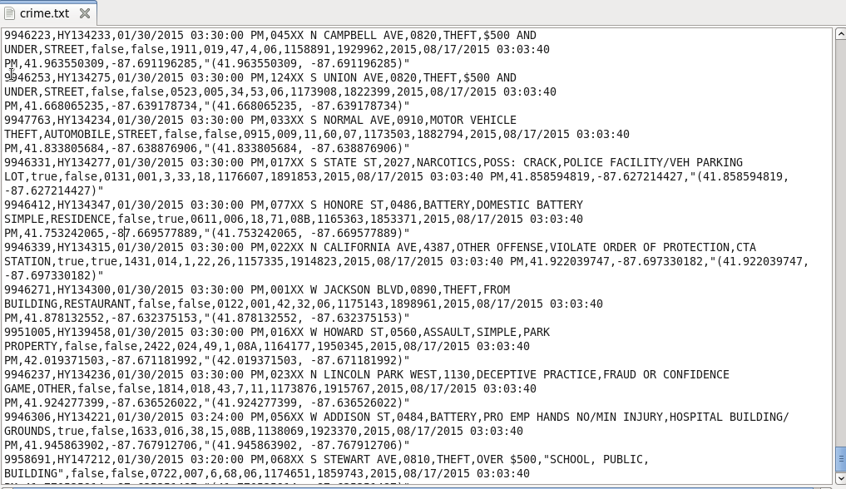

QUES1 )

DRIVER

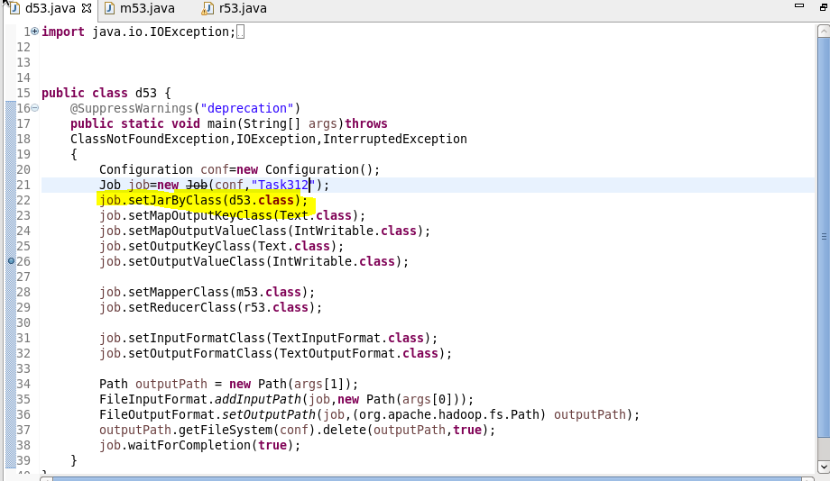

MAPPER

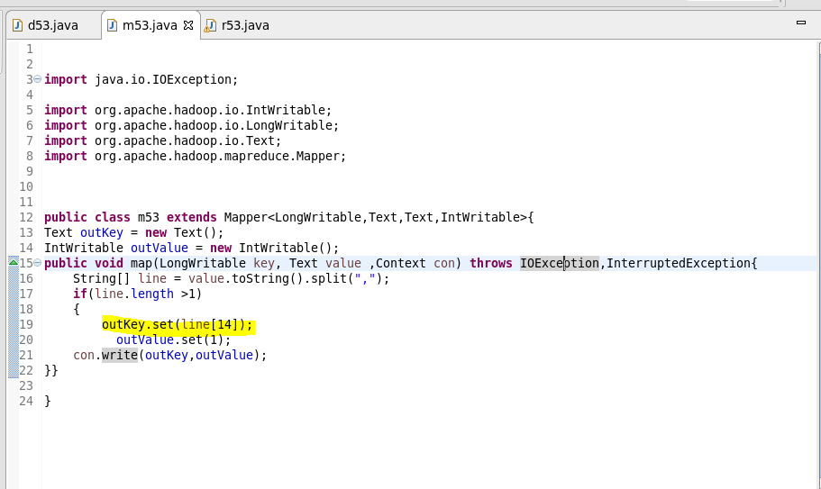

REDUCER

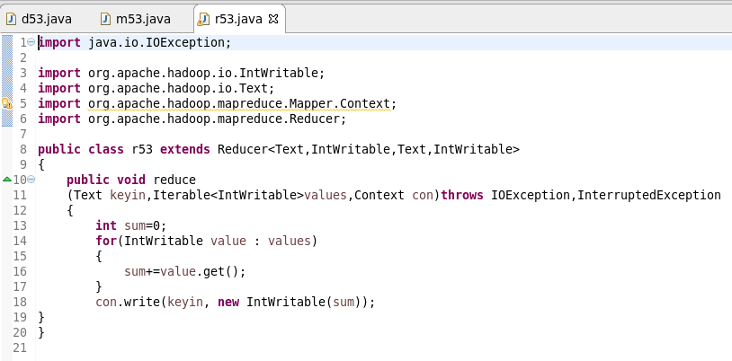

RUNNING JAR FILE

Hadoop jar proj1.1jar /crime.txt /proj_op1.2

OUTPUT

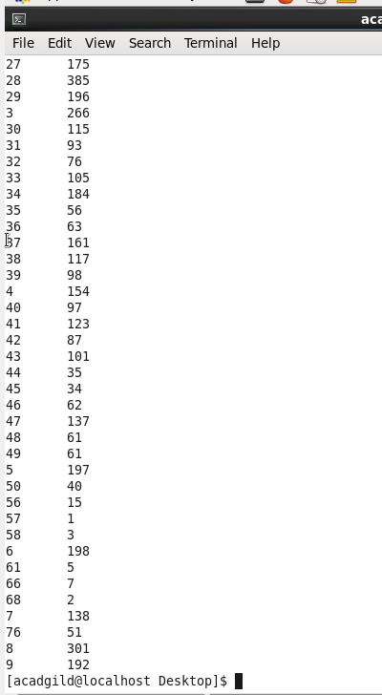

Ques2)



Mapper

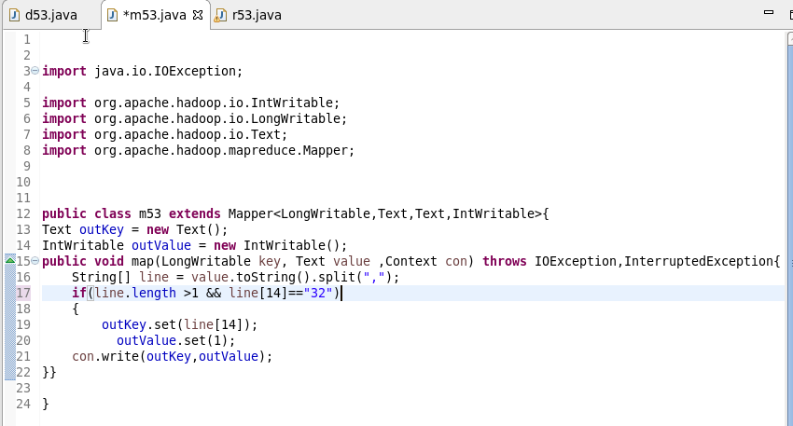

Reducer



Output

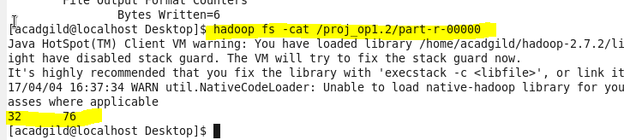

Ques3)

driver



Mapper

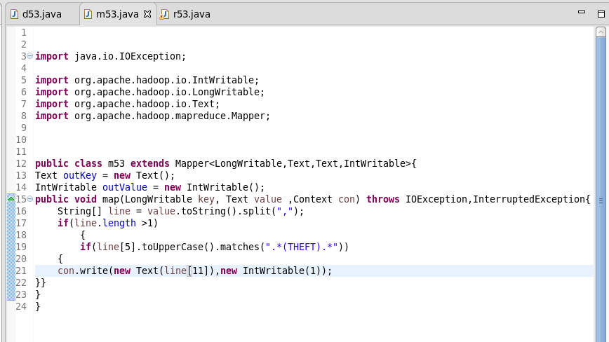

Reducer



Output

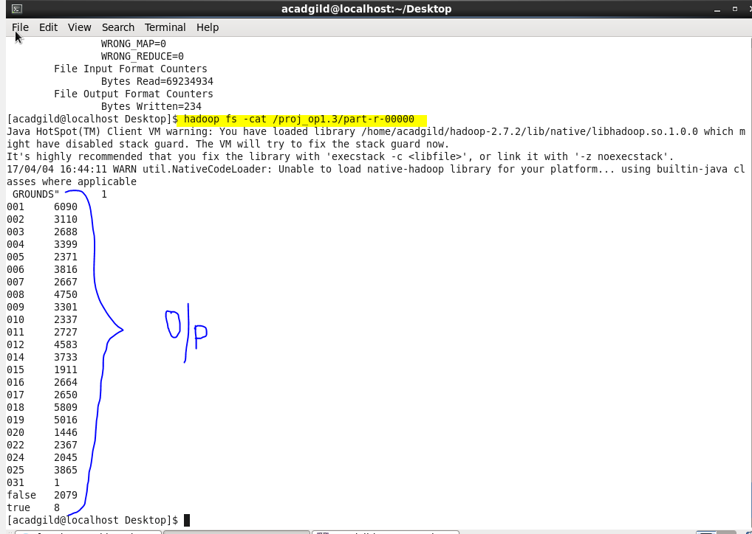

Ques4)

Driver



Mapper

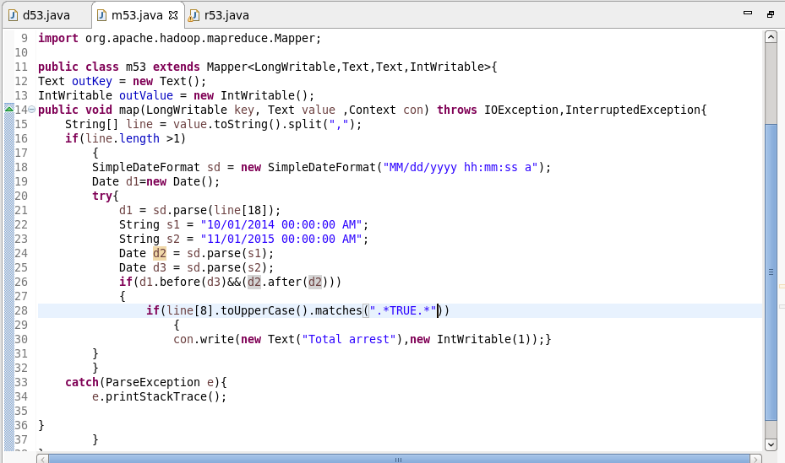

Reducer



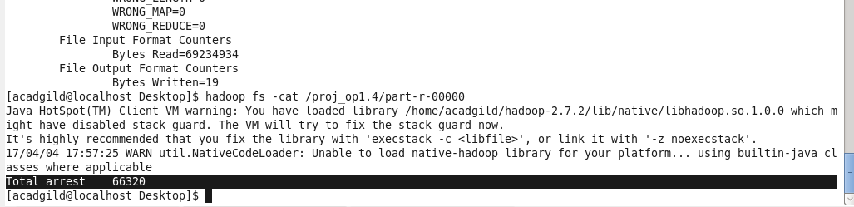

Pig script

Ques1)

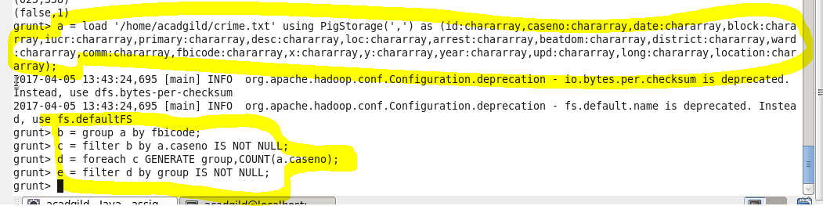

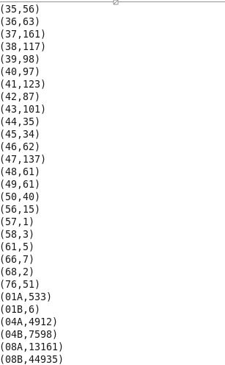

Q2)

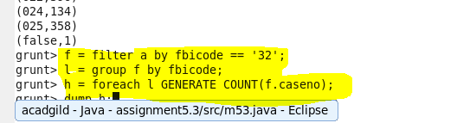

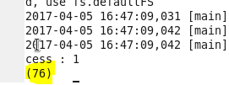

Q3)

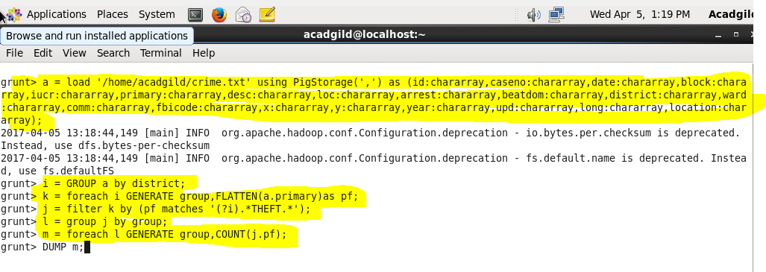

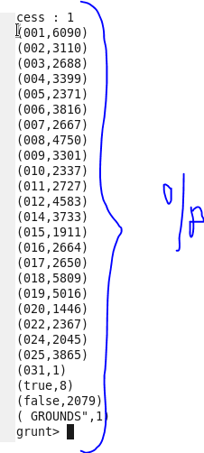

Q4)

